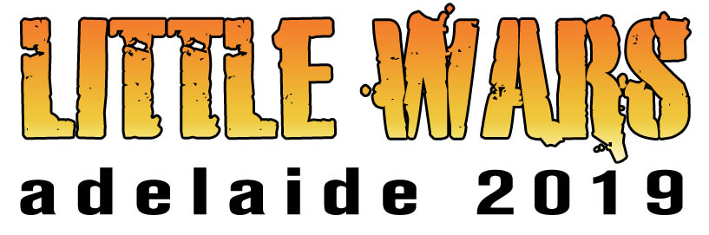

2019 Bring and Buy Forms

This year, the Bring and Buy stand will be run by Stu Williams.

There are two forms we need you to fill out. Print as many copies of them as you need.

Form 1:
A summary form which you will hand to Stu who will use it to keep a record of all sales of your stuff.

Form 2:
The second form contains a number of labels for you to fill in and attached to each item you have for sale. Please ensure that the details on the form 1 match details on form 2!

We've found it works best if you get all of this ready before the day, bagging each item and sticking the appropriate label on it. That way you can hand it over to Stu straight away and not waste your valuable gaming time doing all of the paperwork.

Look forward to seeing you on the day!

Thanks,

Little Wars Team.

ITEM LIST FOR BRING & BUY STALL
Name:
Phone number:
Initials or marking shown on item labels to identify you:
Special instructions:

Item | Description |  |  |  | $ Marked | $ Sold for
1 |  |  |  |  | $ | $
2 |  |  |  |  | $ | $
3 |  |  |  |  | $ | $
4 |  |  |  |  | $ | $
5 |  |  |  |  | $ | $
6 |  |  |  |  | $ | $
7 |  |  |  |  | $ | $
8 |  |  |  |  | $ | $
9 |  |  |  |  | $ | $
10 |  |  |  |  | $ | $
11 |  |  |  |  | $ | $
12 |  |  |  |  | $ | $
13 |  |  |  |  | $ | $
14 |  |  |  |  | $ | $
15 |  |  |  |  | $ | $
16 |  |  |  |  | $ | $
17 |  |  |  |  | $ | $
18 |  |  |  |  | $ | $
19 |  |  |  |  | $ | $
 |  |  |  |  | TOTAL: | $
10% commission (rounded to nearest dollar) goes to Little Wars |  |  |  | 10%: $ | 90%: $
Example
Item Name  Box Of WW2 Miniatures |  |  | Item Name
Owned By  Dave Parker | Price  $25 |  | Owned By | Price  $

Item Name |  |  | Item Name
Owned By | Price  $ |  | Owned By | Price  $

Item Name |  |  | Item Name
Owned By | Price  $ |  | Owned By | Price  $

Item Name |  |  | Item Name
Owned By | Price  $ |  | Owned By | Price  $

Item Name |  |  | Item Name
Owned By | Price  $ |  | Owned By | Price  $

Item Name |  |  | Item Name
Owned By | Price  $ |  | Owned By | Price  $

Item Name |  |  | Item Name
Owned By | Price  $ |  | Owned By | Price  $

Item Name |  |  | Item Name
Owned By | Price  $ |  | Owned By | Price  $

Item Name |  |  | Item Name
Owned By | Price  $ |  | Owned By | Price  $

Item Name |  |  | Item Name
Owned By | Price  $ |  | Owned By | Price  $

